|  |  |  |
| --- | --- | --- |
| Google Merchandise Store | [GO TO REPORT](https://analytics.google.com/analytics/web/?utm_source=pdfReportLink#/report/visitors-overview/a54516992w87479473p92324711/_u.dateOption=last30days&_.useg=builtin1,builtin27,builtin104,builtin7&overview-graphOptions.selected=analytics.nthDay&overview-graphOptions.compareConcept=analytics.newVisits&overview-dimensionSummary.selectedGroup=demographics&overview-dimensionSummary.selectedDimension=analytics.country) |  |
| 2 Test View |  |



**Audience Overview**

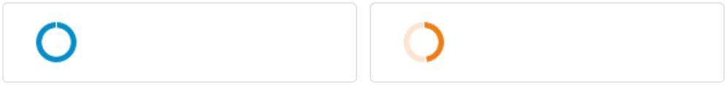

|  |  |  |  |  |
| --- | --- | --- | --- | --- |
| All Users | Bounced Sessions | Sep 20, 2018 - Oct 19, | |  |
|  |  |  |
| 100.00% Users | 48.40% Users |  |  |  |
| Made a Purchase | Direct Traffic |  |  |  |
| 1.62% Users | 19.23% Users |  |  |  |

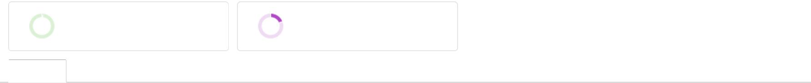

**Overview**

|  |  |  |  |
| --- | --- | --- | --- |
| All Users: | | Users | New Users |
| Bounced Sessions: | | Users | New Users |
| Made a Purchase: | | Users | New Users |
| Direct Traffic: | | Users | New Users |
|  |  |  |  |
| 5,000 | |  | **4,000** |

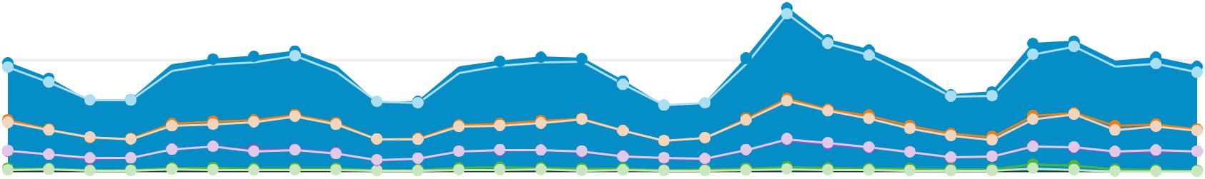

2,500  **2,000**

Sep 22 Sep 29 Oct 6 Oct 13

|  |  |  |  |  |  |
| --- | --- | --- | --- | --- | --- |
| Users |  | New Users |  | Sessions |  |
|  |  |  |
| All Users |  | All Users |  | All Users |  |
| 58,856 |  | 53,164 |  | 78,904 |  |
| Bounced Sessions |  | Bounced Sessions |  | Bounced Sessions |  |
| 28,486 |  | 24,119 |  | 33,204 |  |
| Made a Purchase |  | Made a Purchase |  | Made a Purchase |  |
| 954 |  | 693 |  | 2,832 |  |
| Direct Traffic |  | Direct Traffic |  | Direct Traffic |  |
| 11,317 |  | 10,531 |  | 14,372 |  |
| Number of Sessions per User |  | Pageviews |  | Pages / Session |  |
|  |  |  |
|  |  |  |
| All Users |  | All Users |  | All Users |  |
| 1.34 |  | 360,820 |  | 4.57 |  |
| Bounced Sessions |  | Bounced Sessions |  | Bounced Sessions |  |
| 1.17 |  | 33,204 |  | 1.00 |  |
| Made a Purchase |  | Made a Purchase |  | Made a Purchase |  |
| 2.97 |  | 36,812 |  | 13.00 |  |
| Direct Traffic |  | Direct Traffic |  | Direct Traffic |  |
| 1.27 |  | 67,137 |  | 4.67 |  |
| Avg. Session Duration |  | Bounce Rate |  |  |  |
|  |  |  |  |
| All Users |  | All Users |  |  |  |
| 00:02:52 | 42.08% | |  |  |  |

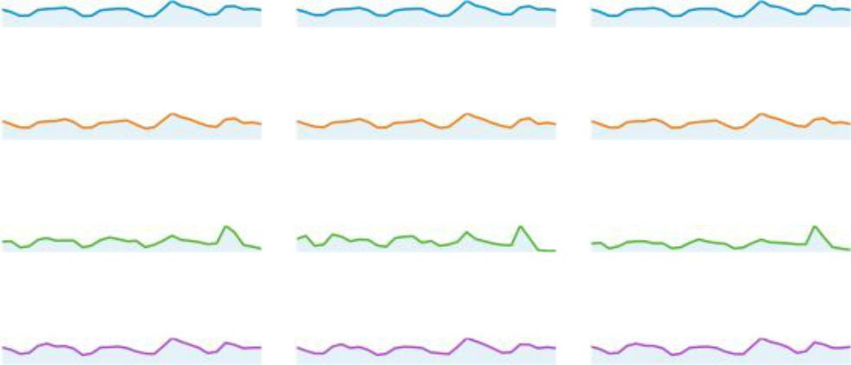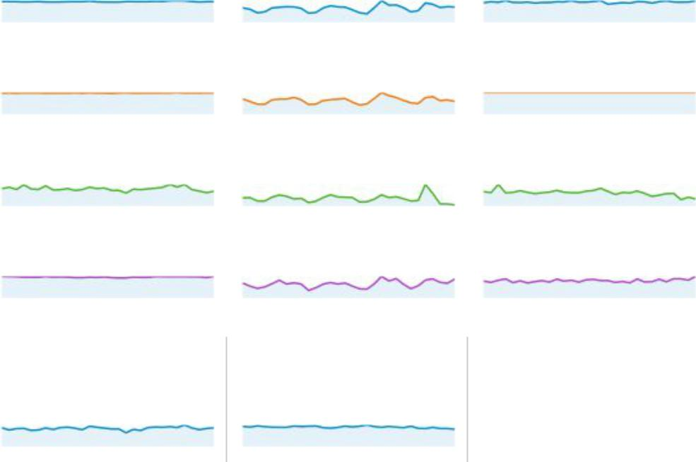

|  |  |  |  |  |  |
| --- | --- | --- | --- | --- | --- |
|  |  | New Visitor |  | Returning Visitor |  |
|  |  |  |  |
| All Users | | |  | Bounced Sessions |  |
| 21.5% |  |  | 21.8% | |  |

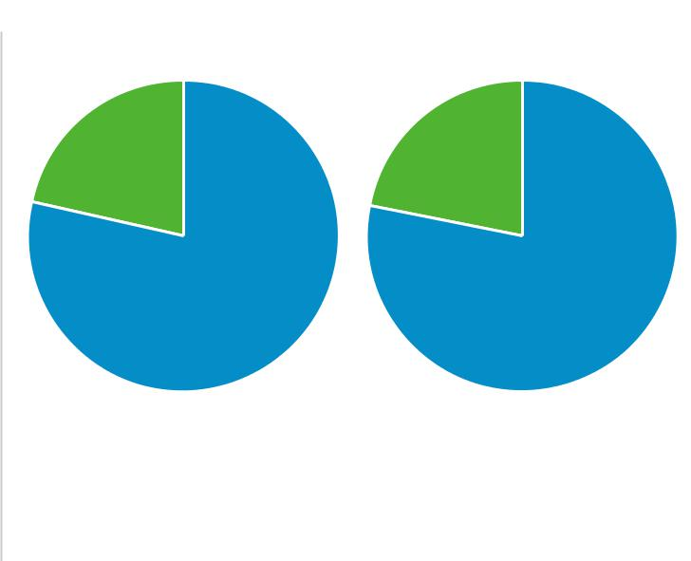

|  |  |
| --- | --- |
| 78.5% | 78.2% |
| Made a Purchase | Direct Traffic |
|  | 17.5% |
| 49.7% | 50.3% |
|  | 82.5% |

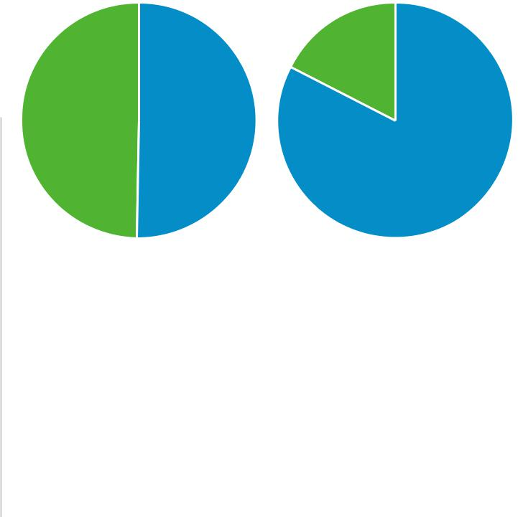

|  |  |
| --- | --- |
| Bounced Sessions | Bounced Sessions |



|  |  |
| --- | --- |
| 00:00:00 | 100.00% |
| Made a Purchase | Made a Purchase |
| 00:08:25 | 11.97% |
| Direct Traffic | Direct Traffic |
| 00:03:03 | 38.70% |
|  |  |

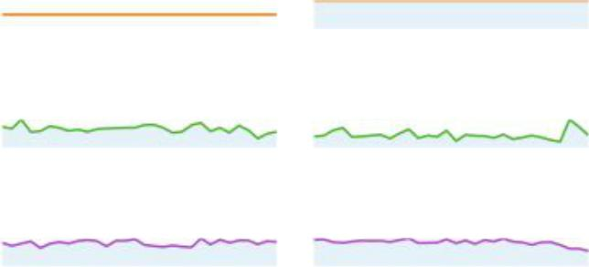

|  |  |  |  |  |  |  |  |  |  |  |  |  |  |  |  |  |
| --- | --- | --- | --- | --- | --- | --- | --- | --- | --- | --- | --- | --- | --- | --- | --- | --- |
|  | **Country** | **Users** | **% Users** | | | | | | | | | | | | |  |
|  |  |  |  |  |  |  |  |  |  |  |  |  |  |  |  |  |
| 1. | United States |  |  |  |  |  |  |  |  |  |  |  |  |  |  |  |
|  |  |  |  |  |  |  |  |  |  |  |  |  |  |  |  |  |
|  | All Users | 27,180 |  |  |  |  |  |  |  |  |  |  | 45.64% | | |  |
|  |  |  |  |  |  |  |  |  |  |  |  |
|  |  |  |  |  |  |  |  |  |  |  |  |  |  |  |  |  |
|  | Bounced Sessions | 9,781 |  |  |  |  |  |  |  |  |  | 33.64% | | |  |  |
|  |  |  |  |  |  |  |  |  |  |  |
|  |  |  |  |  |  |  |  |  |  |  |  |  |  |  |  |  |
|  | Made a Purchase | 906 |  |  |  |  |  |  |  |  |  | | |  | 91.79% |  |
|  |  |  |  |  |  |  |  |  |  | | |  |  |
|  |  |  |  |  |  |  |  |  |  |  |  |  |  |  |  |  |
|  | Direct Traffic | 5,688 |  |  |  |  |  |  |  |  |  | | | 49.86% | |  |
|  |  |  |  |  |  |  |  |  |  | | |  |
|  |  |  |  |  |  |  |  |  |  |  |  |  |  |  |  |  |
| 2. | India |  |  |  |  |  |  |  |  |  |  |  |  |  |  |  |
|  |  |  |  |  |  |  |  |  |  |  |  |  |  |  |  |  |
|  | All Users | 4,374 |  |  |  |  |  |  |  | 7.34% | | | | |  |  |
|  |  |  |  |  |  |  |  |  |  |
|  |  |  |  |  |  |  |  |  |  |  |  |  |  |  |  |  |
|  | Bounced Sessions | 2,696 |  |  |  |  |  |  |  | | 9.27% | | | |  |  |
|  |  |  |  |  |  |  |  | |  |  |
|  |  |  |  |  |  |  |  |  |  |  |  |  |  |  |  |  |
|  | Made a Purchase | 2 |  | 0.20% | | | | | | | | | |  |  |  |
|  |  |  |  |  |
|  |  |  |  |  |  |  |  |  |  |  |  |  |  |  |  |  |
|  | Direct Traffic | 585 |  | |  |  |  | 5.13% | | | | | | |  |  |
|  |  | |  |  |  |  |  |
|  |  |  |  |  |  |  |  |  |  |  |  |  |  |  |  |  |
| 3. | United Kingdom |  |  |  |  |  |  |  |  |  |  |  |  |  |  |  |
|  |  |  |  |  |  |  |  |  |  |  |  |  |  |  |  |  |
|  | All Users | 3,157 |  | |  |  |  | 5.30% | | | | | | |  |  |
|  |  | |  |  |  |  |  |
|  |  |  |  |  |  |  |  |  |  |  |  |  |  |  |  |  |
|  | Bounced Sessions | 1,904 |  | |  |  |  | | 6.55% | | | | | |  |  |
|  |  | |  |  |  | |  |  |
|  |  |  |  |  |  |  |  |  |  |  |  |  |  |  |  |  |
|  | Made a Purchase | 26 |  | |  | 2.63% | | | | | | | |  |  |  |
|  |  | |  |  |  |  |
|  |  |  |  |  |  |  |  |  |  |  |  |  |  |  |  |  |
|  | Direct Traffic | 438 |  | |  | | 3.84% | | | | | | |  |  |  |
|  |  | |  | |  |  |  |
|  |  |  |  |  |  |  |  |  |  |  |  |  |  |  |  |  |
| 4. | Canada |  |  |  |  |  |  |  |  |  |  |  |  |  |  |  |
|  |  |  |  |  |  |  |  |  |  |  |  |  |  |  |  |  |
|  | All Users | 1,995 |  | |  | 3.35% | | | | | | | |  |  |  |
|  |  | |  |  |  |  |
|  |  |  |  |  |  |  |  |  |  |  |  |  |  |  |  |  |
|  | Bounced Sessions | 847 |  | |  | 2.91% | | | | | | | |  |  |  |
|  |  | |  |  |  |  |
|  |  |  |  |  |  |  |  |  |  |  |  |  |  |  |  |  |
|  | Made a Purchase | 12 |  | 1.22% | | | | | | | | | |  |  |  |
|  |  |  |  |  |
|  |  |  |  |  |  |  |  |  |  |  |  |  |  |  |  |  |
|  | Direct Traffic | 378 |  | |  | 3.31% | | | | | | | |  |  |  |
|  |  | |  |  |  |  |
|  |  |  |  |  |  |  |  |  |  |  |  |  |  |  |  |  |
| 5. | Germany |  |  |  |  |  |  |  |  |  |  |  |  |  |  |  |
|  |  |  |  |  |  |  |  |  |  |  |  |  |  |  |  |  |
|  | All Users | 1,395 |  | | 2.34% | | | | | | | | |  |  |  |
|  |  | |  |  |  |
|  |  |  |  |  |  |  |  |  |  |  |  |  |  |  |  |  |
|  | Bounced Sessions | 902 |  | | | 3.10% | | | | | | | |  |  |  |
|  |  | | |  |  |  |
|  |  |  |  |  |  |  |  |  |  |  |  |  |  |  |  |  |
|  | Made a Purchase | 1 |  | 0.10% | | | | | | | | | |  |  |  |
|  |  |  |  |  |
|  |  |  |  |  |  |  |  |  |  |  |  |  |  |  |  |  |
|  | Direct Traffic | 182 |  | | 1.60% | | | | | | | | |  |  |  |
|  |  | |  |  |  |
|  |  |  |  |  |  |  |  |  |  |  |  |  |  |  |  |  |
| 6. | France |  |  |  |  |  |  |  |  |  |  |  |  |  |  |  |
|  |  |  |  |  |  |  |  |  |  |  |  |  |  |  |  |  |
|  | All Users | 1,388 |  | | 2.33% | | | | | | | | |  |  |  |
|  |  | |  |  |  |
|  |  |  |  |  |  |  |  |  |  |  |  |  |  |  |  |  |
|  | Bounced Sessions | 922 |  | | | 3.17% | | | | | | | |  |  |  |
|  |  | | |  |  |  |
|  |  |  |  |  |  |  |  |  |  |  |  |  |  |  |  |  |
|  | Made a Purchase | 0 |  | 0.00% | | | | | | | | | |  |  |  |
|  |  |  |  |  |
|  |  |  |  |  |  |  |  |  |  |  |  |  |  |  |  |  |
|  | Direct Traffic | 240 |  | | 2.10% | | | | | | | | |  |  |  |
|  |  | |  |  |  |
|  |  |  |  |  |  |  |  |  |  |  |  |  |  |  |  |  |
| 7. | Japan |  |  |  |  |  |  |  |  |  |  |  |  |  |  |  |
|  |  |  |  |  |  |  |  |  |  |  |  |  |  |  |  |  |
|  | All Users | 1,377 |  | | 2.31% | | | | | | | | |  |  |  |
|  |  | |  |  |  |
|  |  |  |  |  |  |  |  |  |  |  |  |  |  |  |  |  |
|  | Bounced Sessions | 766 |  | | | 2.63% | | | | | | | |  |  |  |
|  |  | | |  |  |  |
|  |  |  |  |  |  |  |  |  |  |  |  |  |  |  |  |  |
|  | Made a Purchase | 4 |  | 0.41% | | | | | | | | | |  |  |  |
|  |  |  |  |  |
|  |  |  |  |  |  |  |  |  |  |  |  |  |  |  |  |  |
|  | Direct Traffic | 364 |  | | | 3.19% | | | | | | | |  |  |  |
|  |  | | |  |  |  |
|  |  |  |  |  |  |  |  |  |  |  |  |  |  |  |  |  |
| 8. | Taiwan |  |  |  |  |  |  |  |  |  |  |  |  |  |  |  |



All Users 1 156  1 94%

|  |  |  |  |  |  |  |  |
| --- | --- | --- | --- | --- | --- | --- | --- |
|  | Bounced Sessions | 615 |  |  | 2.12% | |  |
|  |  |  |  |
|  |  |  |  |  |  |  |  |
|  | Made a Purchase | 5 |  | 0.51% | | |  |
|  |  |  |
|  |  |  |  |  |  |  |  |
|  | Direct Traffic | 344 |  | | | 3.02% |  |
|  |  | | |  |
|  |  |  |  |  |  |  |  |
| 9. | Spain |  |  |  |  |  |  |
|  |  |  |  |  |  |  |  |
|  | All Users | 1,132 |  | | 1.90% | |  |
|  |  | |  |
|  |  |  |  |  |  |  |  |
|  | Bounced Sessions | 751 |  | | | 2.58% |  |
|  |  | | |  |
|  |  |  |  |  |  |  |  |
|  | Made a Purchase | 3 |  | 0.30% | | |  |
|  |  |  |
|  |  |  |  |  |  |  |  |
|  | Direct Traffic | 179 |  | | 1.57% | |  |
|  |  | |  |
|  |  |  |  |  |  |  |  |
| 10. | Netherlands |  |  |  |  |  |  |
|  |  |  |  |  |  |  |  |
|  | All Users | 982 |  | | 1.65% | |  |
|  |  | |  |
|  |  |  |  |  |  |  |  |
|  | Bounced Sessions | 648 |  | | 2.23% | |  |
|  |  | |  |
|  |  |  |  |  |  |  |  |
|  | Made a Purchase | 0 |  | 0.00% | | |  |
|  |  |  |
|  |  |  |  |  |  |  |  |
|  | Direct Traffic | 193 |  | | 1.69% | |  |
|  |  | |  |
|  |  |  |  |  |  |  |  |



* 2018 Google